- Slider

This section must always fit within the dimensions of the screen- what ever the screen size.

You can see examples of how this works on the following links:

http://travelprofessionals.club/
http://clubmiles.travel/
http://destinationspecialist.co.uk/
https://www.major.travel/partners/

- The slider must never go over the fold of the screen
- The slider must never be less tall than the height of the screen

In all the links above you will see that this works on all screen sizes

- Margin and Font Sizes

I want you to adjust the border margin for larger scree sizes.

- This is how the the header should look on a 27” screen:

This is how it looks on the HTML you sent

- This is how the CONTENTENT HELPS section should look on the 27” screen:

This is how it looks on the HTML

- Strength in numbers Should look

HTML currently:

- Flip Around cards need to be more square- on the HTML they are very narrow

Should look:

HTML

- The same applies to smaller screens. The page should adjust better. So on a 15” laptop it should look like this

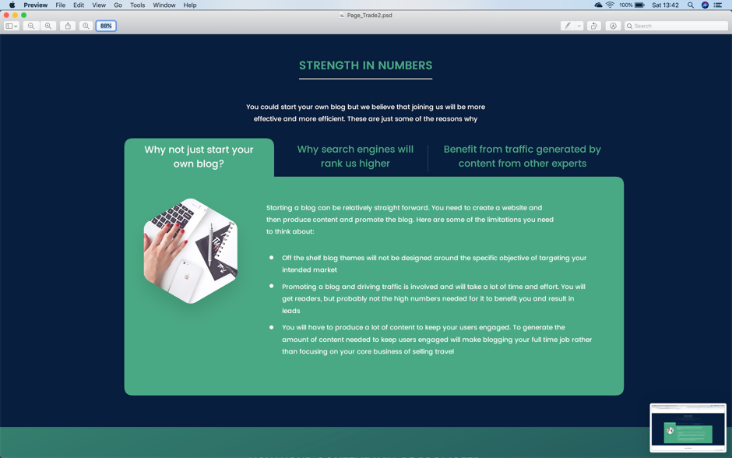

But this is how it looks on the HTML:

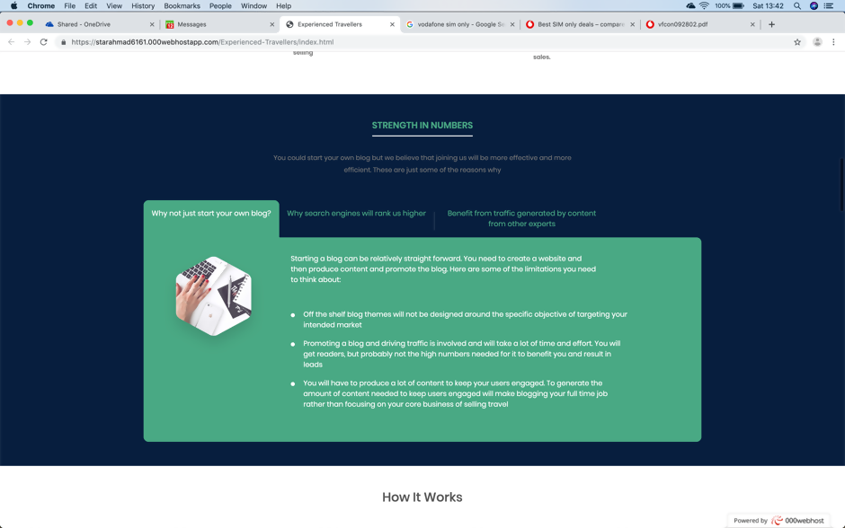
- Mobile
  - How Content Helps

This section should use more of the width of the screen. The margins are too big:

  - Strength in Numbers

This section on mobile- the content should open under the title and not below the 3rd title. Something like this:

